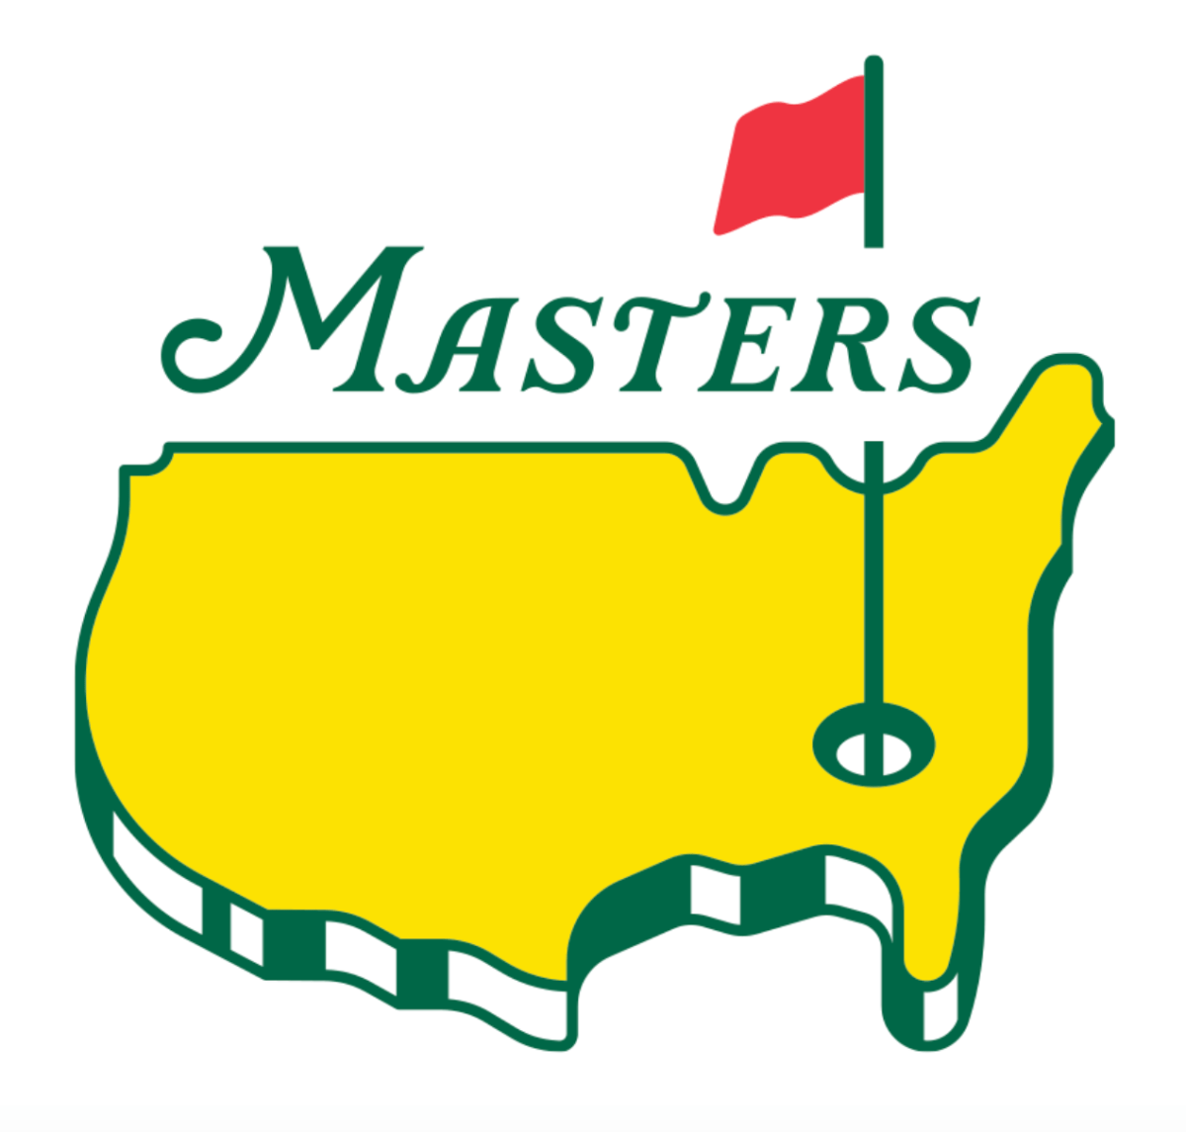
Holdrege Country Club Master’s
Annual Fund Raiser
Friday, April 12, 2024
JB’s Sports Bar
Social Hour 5:30-6:30 pm
Meal 6:30-7:30
Silent Auction
(Serving New York Steak, Cheesy Potatoes, Salad)
Free Will Donation
RSVP: April 10th – Phone: 308-991-7694
Rich, Roger, KJ, Tim, Flip
“Let’s help get the NEW Clubhouse going!”

